**San Francisco (SF Pro) Working with Git and GitHub:**

**1. Create a New Repository on GitHub**

1. Go to [GitHub](https://github.com/) and log in.
2. Click on **"New Repository"**.
3. Enter a repository name (e.g., my-git-project).
4. Choose **Public** or **Private**.
5. Do NOT select "Initialize with README" .
6. Click **Create Repository**.

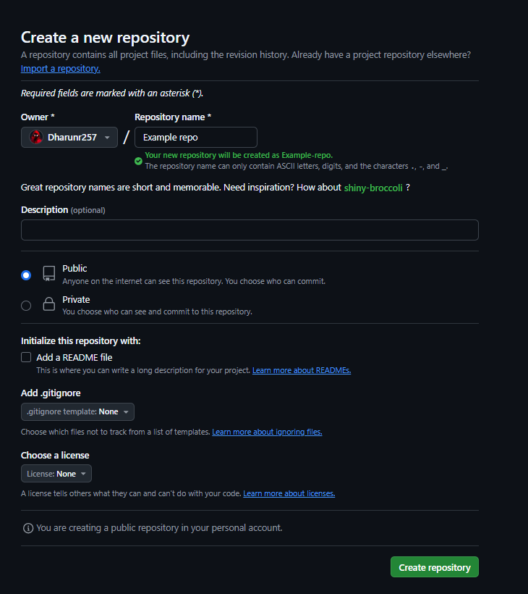**Screenshot:**

**2. Initialize Git Locally**

1. Open a terminal / command prompt.
2. Navigate to the directory where you want to create the project:
3. Type “mkdir my-git-project “ and “cd my-git-project” .
4. Initialize Git inside the folder:
5. Type “git init”

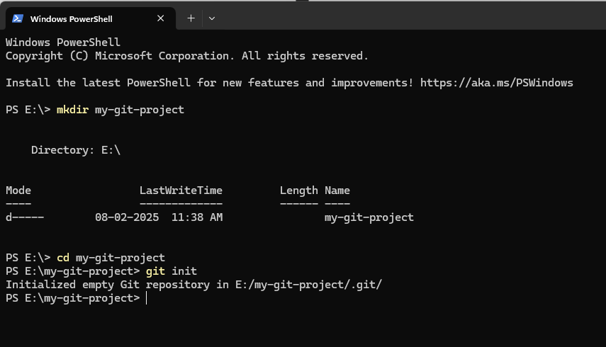**Screenshot:**

**3. Link the Local Repository to GitHub**

1. Add the remote GitHub repository:
2. Type “git remote add origin <https://github.com/your-username/my-git-project.git>” / “https://github.com/Dharunr257/Example-repo.git”
3. Verify the remote repository:
4. Type “git remote -v”

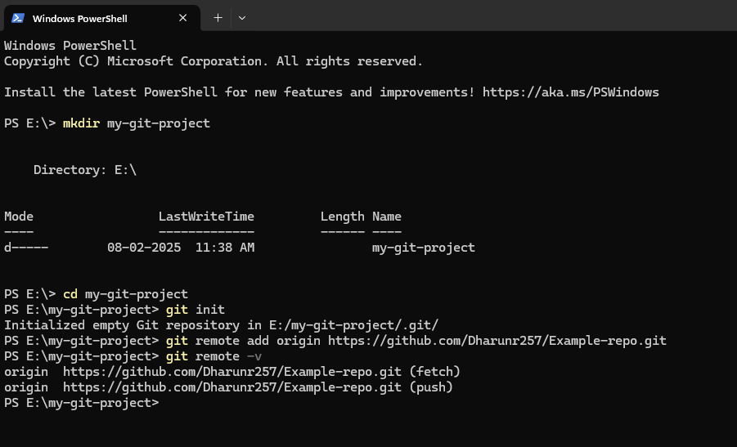**Screenshot:**

**4. Add and Commit Files**

1. Create a new file:
2. Type “echo "<h1>Hello, Git!</h1>" > index.html”
3. Check the Git status:
4. Type “git status”
5. Stage the file:
6. Type “git add index.html”
7. Commit the file with a message:
8. Type “git commit -m "Initial commit: Added index.html"”

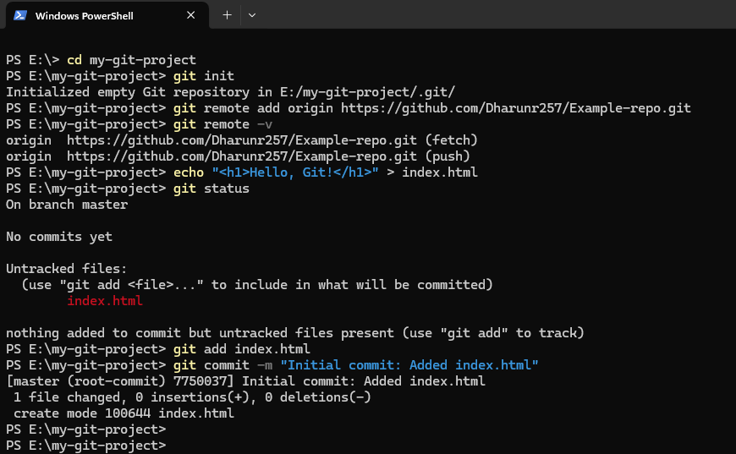**Screenshot:**

**5. Push to GitHub**

1. Push the local changes to GitHub:
2. Type “git branch -M main’ , then
3. Type “git push -u origin main”
4. Go to your GitHub repository and **refresh the page**. You should see the index.html file.

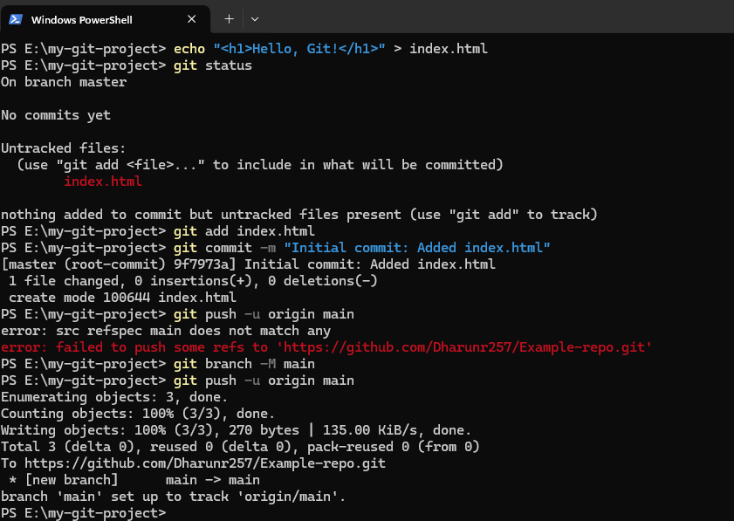**Screenshot:**

